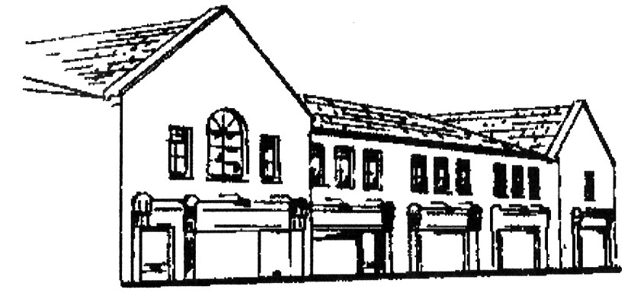

Dunshaughlin Dental Centre
www.dunshaughlindental.com
info@dunshaughlindentalcentre.com
01 8259787

Filler Aftercare

- The effect of your treatment is immediate. Filler can be slightly mobile for a few hours following the procedure so it is important that you keep facial movements minimal and do not rub or massage the area for the rest of the day.

- Immediately after treatment it is normal for there to be slight redness, swelling and tenderness around the treated area. These signs will gradually disappear in a few days. Wash and dry your face with gentle patting movements.

- It is possible that you may be able to see or feel where the product has been placed for about two weeks after treatment. As the filler gradually incorporates into the matrix of your skin, these signs will lessen. If you have had a stronger, more uplifting filler, it is possible that the filler will be palpable for longer.

- Please avoid the use of make up for the rest of the day to prevent the introduction if infection into the injection sites.

- Do not have facial beauty treatments or massage for two weeks following treatment and avoid exposure to strong sunlight, very cold temperatures, saunas and solariums for the same length of time.

- If there is discomfort following treatment you may take paracetomol. Avoid the use of aspirin, ibuprofen or other anti-inflammatory drugs as they increase the risk of bruising.

- Lip treatment generally takes a little longer to settle and may feel tender and appear uneven – this will gradually resolve itself in the first week and should not affect the final result.

- There is a chance of bruising with filler treatments, caused both through the injection and sometimes through the pressure of the product on the capillaries under the skin. Bruising may be apparent at the time of treatment or may develop later and may be anything from more likely mild to moderate or occasionally heavy. This is an unfortunate side effect of filler treatments. Bruising will subside with time and the use of arnica cream can sometimes be helpful. Cool compresses for two days following treatment can help. After two days, warm compresses will encourage the blood supply to remove traces of the bruise.

- Although your treatment result is immediate the overall result will look much better in about two weeks when any trauma has subsided and the plumping effect of the product has really started to take effect.

