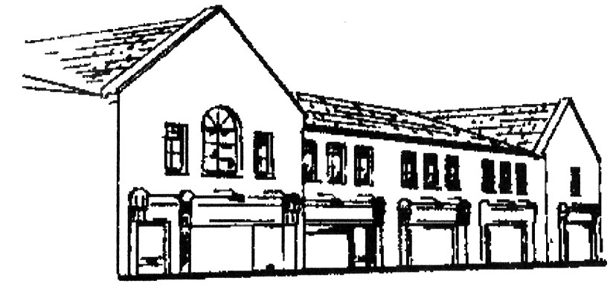

Dunshaughlin Dental Centre
www.dunshaughlindental.com
info@dunshaughlindentalcentre.com
01 8259787

Botox Aftercare

- You can help activate the Botox by gently exercise the muscles that have been treated i.e. frown and smile as frequently as possible.
- When you feel the muscles relaxing (4-10 days) massage the area with your regular moisturiser twice a day.
- Some patients experience slight discomfort around the treatment area for a short period after treatment.
- Bruising can be avoided or minimised by avoiding aspirin and alcohol for 24 hours pre and post treatment.
- You may experience temporary swelling or bruising around the site of treatment. This will usually settle within a day or two. Some patients experience a headache after treatment for which you may take paracetomol.
- The results are not permanent and the duration will differ from person to person.
- The treatment normally takes 4-10 days to take effect.
- Side effects, if they occur, are usually temporary and mild to moderate.

Most common reported side effects

- Tenderness.
- Bruising.
- Temporary Headache.
- Drooping of the eyelid or brow.
- Excessive watering of the eye.
- Mild inflammation of the surface of the eye.

Less common side effects

- Inflammation of the surface of the eye.
- Everson or Inversion of the eyelids.
- Light sensitivity / double vision.
- Dizziness, rash, tiredness.
- Facial weakness/droop/asymmetry.
- Allergic reaction.

Should you experience any of these symptoms following treatment, please contact your practitioner.
We hope you are happy with your treatment. Please remember, however, that the treatment will usually only last 3-4 months and movement will start to return any time from 4 weeks.

